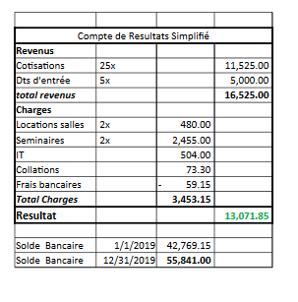

RAPPORT FINANCIER 2019